Basic Atoms and Bonding PracticeASNWER KEY

1. What is the name for the three subatomic particles and their charges? _proton (positive)_, _electron (negative)_, &_neutron (neutral)_.
2. What are the 2 parts to an atom? _nucleus_ & _electron cloud_
3. The two subatomic particles that exist in the nucleus are _proton_&_neutron_.
4. Outside the nucleus is the _electron__cloud_where _electrons_exist.
5. Complete the chart showing you can read a periodic table.

|  |  |  |  |  |  |  |
| --- | --- | --- | --- | --- | --- | --- |
| Element | # Protons | # Neutrons | # Electrons | # Rings | # Valence e- | # e- lost or gained to get 8 |
| Carbon | 6 | 6 | 6 | 2 | 4 | 4+/- |
| Hydrogen | 1 | 0 | 1 | 1 | 1 | -1 |
| Nitrogen | 7 | 7 | 7 | 2 | 5 | +3 |
| Oxygen | 8 | 8 | 8 | 2 | 6 | +2 |
| Phosphorus | 15 | 16 | 15 | 3 | 5 | +3 |
| Sulfur | 16 | 16 | 16 | 3 | 6 | +2 |
| Lithium | 3 | 4 | 3 | 2 | 1 | -1 |
| Iodine | 53 | 74 | 53 | 5 | 7 | +1 |
| Argon | 18 | 22 | 18 | 3 | 8 | 0 |
| Silicon | 14 | 14 | 14 | 3 | 4 | 4+/- |
| Rubidium | 37 | 48 | 37 | 5 | 1 | -1 |
| Fluorine | 9 | 10 | 9 | 2 | 7 | +1 |
| Francium | 87 | 136 | 87 | 7 | 1 | -1 |
| Boron | 5 | 6 | 5 | 2 | 3 | -3 |
| Lead | 82 | 125 | 82 | 6 | 82 | 4+/- |

1. Construct a Bohr diagram and Lewis structure for:
   1. Sodium
   2. Chlorine

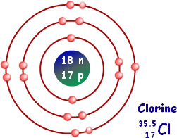a. b.

LEWIS STRCTURE

LEWIS STRUCTURE

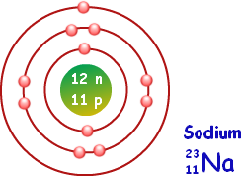



1. Bonding happens because elements are trying to achieve stability. They achieve stability when they get _8_ electrons in their outer shell. This outer shell is called the ­_valence_shell. This is called the__octet_rule.
2. Atoms can achieve _8_ electrons by either _swapping_or_sharing_electrons.
3. Ionic bonds form when atoms _swap_electrons.
4. Each atom will end up with _8_atoms in their valence shell.
5. Diagram the ionic bonds for the following: Ionic bonding is flexible, but the ratios of elements in ionic compounds are consistent. The quantities of each element below are NOT listed. You can figure out the ratio adding more of one of the elements listed ensuring all valence electrons can find an electron acceptor.
   1. Sodium + Chlorine b. Magnesium + Iodine
   2. Potassium + Iodine d. Sodium + Oxygen
6. Covalent bonds form when atoms _share_electrons.
7. Diagram the bond for the following: Covalent bonds require you know the elements plus the relative quantities of each. Illustrate exactly what’s listed.
   1. Hydrogen + Hydrogen c. 2 Hydrogen + Oxygen



* 1. Carbon + 2 Oxygen d. Carbon + 4 Hydrogen

1. Many covalent molecules result in a molecule with equal charge distribution. This is called_non_-_polar_.In some covalent molecules, electrons are not shared equally between atoms. These molecules fall under a category called _polar__covalent_molecules because part of the molecule has a _+_ charge while another part has a _-_ charge.
2. Label the positive end and the negative end of the water molecules below. (the fluffy diagram on the left is called a space-filling model and the right one is called a structural formula)

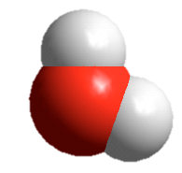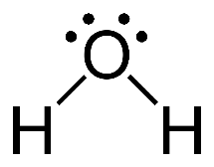

-

+

-

+

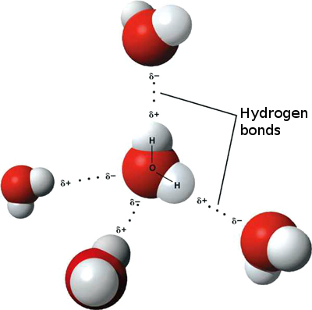

1. Hydrogen bonds don’t occur between atoms of the same molecule. They form between oppositely _charged_atoms of _different_molecules that are both_polar_.
2. Show the hydrogen bonding between these water molecules. Illustrate the negative oxygen connected to the positive hydrogen with dashed lines. The dashed lines are the hydrogen bonds.